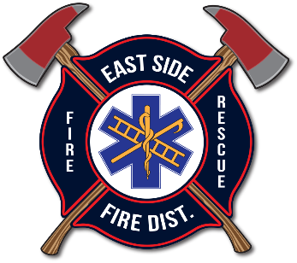
EAST SIDE FIRE DISTRICT
BOARD OF FIRE COMMISSIONERS
REGULAR MEETING AGENDA
February 11, 2026 | 10:30AM
20436 S. Hwy 97, Harrison, ID 83833

Open Regularly Scheduled Commissioners’ Meeting

PLEDGE OF ALLEGANCE

APPROVAL ACTION ITEMS

Agenda: February 11, 2026

Minutes: January 21, 2026

Financials and Expense Report

BUSINESS
- Fire Chiefs Report: Lynn
- EMS Report: Pegoraro
- ESFD Auxiliary Report: Stone
- ACTION ITEM: Approval of KCFR Lease Addendum/Extension
- ACTION ITEM: Approval of Health Benefits Policy in P302
- ACTION ITEM: Approval of Update to Volunteer Policy in P300
- ACTION ITEM: Approval of Audit Engagement Letter for Alpine Summit CPAs

IV. UPCOMING WORK AND CONSIDERATIONS
- Wednesday, March 11th - ESFD Regular Commissioner Meeting

- PUBLIC COMMENT (Per ESFD Policy P200, Public Comment will be limited to 3 minutes per speaker and discussion will be restricted to items on the Business Section of the published agenda, and only to those items.)

VI. ACTION ITEM: CLOSE MEETING

