Access Road Requirements for Single Family Residence Development(s)

Owner: |  | Location: |  | Permit#
Contact: |  | Phone: |  | Total Planned Residences:

Fire Service features required for development within East Side Fire District are determined by the 2018 International Fire Code, Idaho Administrative Procedures Act (IDAPA), Kootenai County and as determined by East Side Fire District.

Fire Apparatus Access Roads-
Fire Apparatus Access Road - A road that provides fire apparatus access, egress from a fire station to a facility, building or portion thereof including providing access, egress for more than 5 single family dwellings.

- Unobstructed width of not less than twenty (20) feet exclusive of shoulders, except for approved security gates. The fire code official shall have the authority to require an increase in the minimum width requirements where they are inadequate for fire or rescue operations.
  - Dead end with a length >500’ and less than 750’ requires a width of 26’ exclusive of shoulders.
  - Dead end with a length >750’ requires special approval.
- Unobstructed minimum clearance height of thirteen (13) feet six (6) inches.
- Extend to within 150 feet of all portions of the facility and all portions of the exterior walls of the first story of the building as measured by an approved route around the exterior of the building or facility.
- The gradient of fire apparatus access roads shall not exceed ten (10) percent unless approved by the fire code official.
- Dead-end fire apparatus access roads in excess of 150 feet in length shall have an approved fire apparatus turn-around.
- A minimum turning radius of twenty-five (25) feet on all corners. Measured to the inside of corner.
- A minimum distance of forty (40) feet between switch backs. Measured inside to inside of sixty (60) foot center radius.
- All private roadways/driveways shall enter county or state roadways at a right angle and meet the radius requirements above or as approved by fire code official. Roadways/driveways must comply with county and state requirements.
- Fire apparatus access roads shall be designed and maintained to support the imposed loads of fire apparatus and surfaced to provide all weather driving capabilities and shall be passable year-round.
- Bridges and elevated surfaces shall be designed to support the imposed loads of fire apparatus.
  - Travel distance and bridge or culvert under ten (10) feet in length must support seventeen (17) tons, (34,000 lbs.)
  - Travel distance and bridge or culvert over ten (10) feet in length must support thirty (30) tons, (60,000 lbs.)
  - Vehicle load limits shall be posted at both entrances to bridges where required by the fire code official.
- Streets and private roads shall be identified with approved signs, signage shall be visible from both directions of travel.
Continued on other side

Fire Apparatus Access Roads (cont.)
- The fire code official is authorized to require signage or approved markings to identify areas on road where no vehicle parking or other obstruction is allowed.
- Traffic calming devices shall be prohibited unless approved by the fire code official.
- The fire code official is authorized to require the installation and maintenance of gates or other approved
barricades across fire apparatus access roads, trails or other accessways.
- Where security gates are installed, they shall have an approved means of emergency operation and shall be operational at all times.
- The fire code official is authorized to require more than one fire apparatus access road based on the potential for impairment of a single road.

The above, represents general requirements and is not intended to be all inclusive. East Side Fire District’s Fire Chief or designee shall have the authority to change or modify any fire service feature requirements for structures constructed or relocated within fire district jurisdiction.

Turnaround Requirements

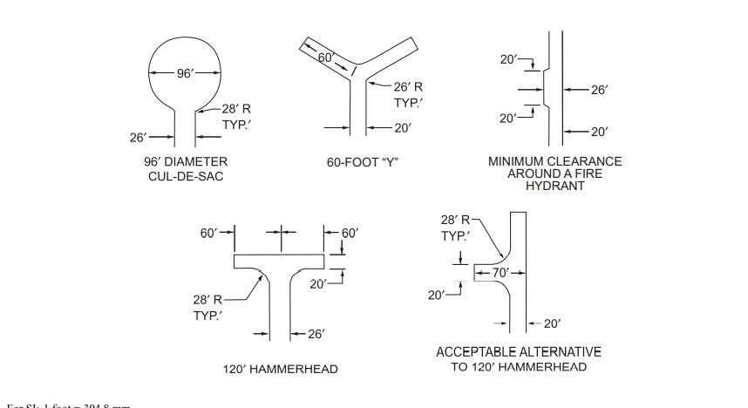

Owner Signature ____________________________________________ Date: __________________

Developer Signature__________________________________________ Date: __________________

Inspector Signature __________________________________________ Date: __________________

Fire Chief Signature _________________________________________ Date: __________________

