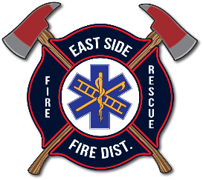
EAST SIDE FIRE DISTRICT
BOARD OF FIRE COMMISSIONERS
SPECIAL MEETING AGENDA
December 11, 2025 | 10:30AM
20436 S. Hwy 97, Harrison, ID 83833

Open Commissioners’ Special Meeting

- APPROVAL ACTION ITEMS
- Special Meeting Agenda: December 11, 2025

- BUSINESS
- EXECUTIVE SESSION to consider the evaluation of an employee, as per Idaho Code74-206(1) (b)

- CLOSE EXECUTIVE SESSION

- ACTION ITEM: Approval of RLH Proposal

- ACTION ITEM: CLOSE MEETING

