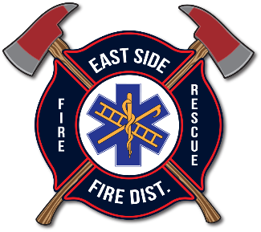
EAST SIDE FIRE DISTRICT
BOARD OF FIRE COMMISSIONERS
REGULAR MEETING AGENDA
December 10, 2025 | 10:30AM
20436 S. Hwy 97, Harrison, ID 83833

Open Public Hearing for Amendment to FY 2025 Budget
- Open Public Hearing
- Close Public Hearing

Open Regularly Scheduled Commissioners’ Meeting

PLEDGE OF ALLEGIANCE

APPROVAL ACTION ITEMS

Agenda: December 10, 2025

Minutes: November 12, 2025

Financials and Expense Report

- III-A ANNUAL REPORT: Megan Lockwood via ZOOM

BUSINESS
- Fire Chiefs Report: Lynn
- EMS Report: Pegoraro
- ESFD Auxiliary Report: Stone
- ACTION ITEM: Approval of Updated Incentive Points Amount for Volunteers NTE $45,747.50.
- ACTION ITEM: Approve Amendment of FY 2025 Budget
- DISCUSSION: Giving Tree (Loewe)
- DISCUSSION: Christmas Banquet: Ador
- ACTION ITEM: Approve Acrisure Insurance Renewal for 2025 (If paperwork comes on time)

IV. UPCOMING WORK AND CONSIDERATIONS
- Thursday, December 11th – ESFD Special Meeting
- Wednesday, January 14th - ESFD Regular Commissioner Meeting

- PUBLIC COMMENT (Per ESFD Policy P200, Public Comment will be limited to 3 minutes per speaker and discussion will be restricted to items on the Business Section of the published agenda, and only to those items.)

VI. ACTION ITEM: CLOSE MEETING

